|  |  |
| --- | --- |
| **Article ID:** | 2039 |
| **Article Name:** | The automatic parboil function of my hob doesn’t work correctly. |
| **Topic Location:** | Cooking/Hob/usage/Performance |
| **Meta-data:** | Parboil, Automatic, Shuts off, Disconnect |
| **Related Articles:** |  |
| **Related Questions:** |  |

PNC

DIY

Safety

Link

Email

Book Engineer

Multimedia

Brand

**Article Content:**

The automatic parboil function will only be activated if you select a power level using the” +” button. Depending on the power level selected the automatic parboil function will be activated during a present time (see picture below).

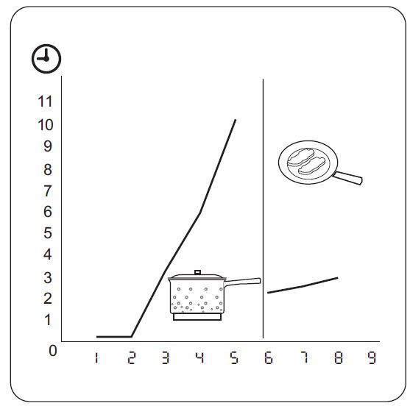If you select the power level using the “-“ button the automatic parboil function will not be activated.